**MR3522 Lab 5: WSR-88D Radar Data in an Oklahoma Supercell**

****Purpose: Interpret dual-polarimetric radar variables from WSR-88D NEXRAD radar data from the EF5 Moore, OK tornado of May 20, 2013. (The other famous Moore tornado was on May 3, 1999, and that tornado actually hit almost the exact same area as an F5!) The picture to the right is one of the 2013 tornado at about the time of the radar imagery provided in this lab.

*Starting up*

1. In the file viewer of your JupyterLab, go to “MR3522/Lab5” and double click MooreTornado_20130520.ipynb.
2. Show line numbers in each cell by clicking “View” -> “Show Line Numbers” in the menu bar.

*About the code*

After running the code, just toggle the drop-down menu and slider for the images at the end of the Jupyter notebook. You can, if you wish, alter the scale of the color bars used in the cell labeled “Set up for plotting some radar data”. Manually save any figures you want to keep.

*About the data:*

The data represents one volume containing several sweeps. Specifically, the volume contains 14 sweeps at the following elevation angles: 0.48, 0.88, 1.32, 1.80, 2.42, 3.12, 4.0, 5.10, 6.42, 8.0, 10.02, 12.48, 15.60, and 19.51 degrees. The sweep started at 2012 UTC and ended at 2016 UTC on 20 May 2013. The WSR-88D radars are S-band radars with wavelengths of approximately 10.7 cm.

*Plotting:*

1. Run the code. A plot of radar reflectivity factor in dB*Z* should appear. When you scroll your mouse on the plot, the x and y values that appear correspond to west-east or north-south distances from the radar in kilometers. You can adjust the variable plotted by selecting from the “Product” drop-down menu, and you can control the elevation angle (or sweep) viewed by toggling the “Sweep” slider.
   1. **What are the radar-relative coordinates of the tornado closest to the radar?**

**25 km west and 1.4 km south of the radar.**

* 1. **What is the approximate maximum radar reflectivity factor observed in this tornado?**

**Around 68.5 dB*Z.* Anything over 64 dB*Z* is easy to find.**

1. For any of the plots, you can zoom in by click the zoom tool and drawing a box around the supercell closest to the radar containing the tornado. If you mess up zooming, you can click the “home” icon and zoom back out then try again, or you can click the back arrow to go the zoom level you just had. The crossed arrows icon allow you to pan around in the image.
2. Look at the Doppler radial velocity field next.
   1. **Approximate the Nyquist velocity at the lowest tilt.**

**26.5 m/s, although +/- 25.5 m/s is the highest magnitude for radial velocity I could find for the 0.5° tilt.**

* 1. **Using the approximation in 3a, state the corresponding PRF.**

**Use the equation for Nyquist velocity in the notes. The wavelength is 0.107 m.**

**For 26.5 m/s: 991 Hz**

**For 25.5 m/s: 953 Hz**

* 1. You should end up with a Doppler velocity plot that looks similar to this at the lowest elevation angle:

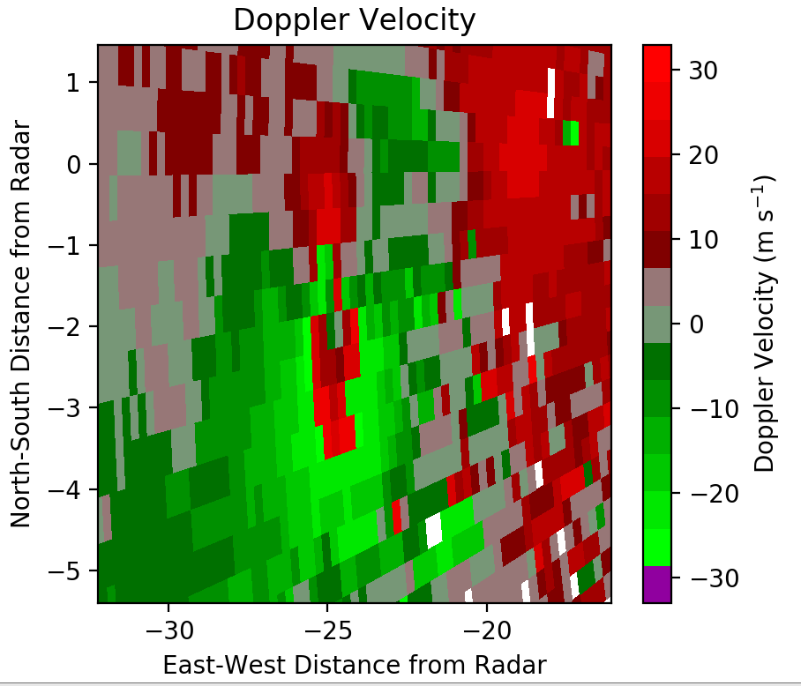

There are two areas near the tornado with strong outbound velocities reported. They are circled in the figure above. One of those areas is folded and the other is not. **Which area of apparent outbound velocities is folded? How do you know?**

**The debris signature of the tornado (with cyclonic vorticity) is located near (-25 km, -1.4 km) based on the answer to Question 1a. Therefore, we expect inbound velocities to the south of the debris signature and outbound velocities to its north. The “outbound” velocities to the south, therefore, are actually folded inbound velocities.**

1. **Based on the Doppler velocities (you can look at any low level for this), deduce the direction of the supercell’s forward motion. Justify your answer based on the distribution of the base velocity field, and not just your sense of which direction the cell should move.**

**Easterly to northeasterly. We are looking at “base” radial velocity. Radial velocity on the south side of the vortex is larger than on the north side because the forward motion vector of the tornado is added to the wind forced by the tornado. The forward motion vector is opposite in direction to the winds on the north side of the tornado but of the same direction with winds south of the tornado. We also see that inbound velocities are primarily seen southwest of the radar, and outbound velocities are seen to the northeast of the radar. This also supports a forward motion of the line of supercells toward the northeast.**

1. **Is the rain heavier in the debris ball or in the echo about 13 km west-north west of the radar site? Based on the radar data, how do you know?**

**Rain is heavier WNW of the radar site, in part of the supercell that is not the “debris ball”. A few variables suggest this. The differential reflectivity in the core of the supercell (~13 km WNW of the radar) is high—about 3 to 5 dB. This is indicative of very large raindrops, which generally only occurred where intense precipitation is occurring. We can deduce that the high reflectivity echo in the tornado is not rain because the correlation coefficient is very low (often less than 0.5), and the differential reflectivity field there is very noisy and averages near zero.**

1. **Report a typical value of correlation coefficient in moderate rainfall, and report a typical value in the debris ball. Why is *ρHV* so low in the debris ball?**

**Typical value in debris ball: Less than 0.5**

**Typical value in moderate rainfall (~35 dB*Z* reflectivity): 0.95 or higher**

**Correlation coefficient is low in the debris ball because large, non-meteorological radar targets are randomly shaped and oriented. This makes the cross-correlation between horizontal and vertical returned signal very low.**

1. **Look now at the cell near (-50, -75) from the radar. It is a supercell with a well-defined V-notch. Use the reflectivity, correlation coefficient, differential reflectivity, and differential phase shift to deduce whether the echo is primarily hail or debris from another tornado. Explain your reasoning.**

**Primarily hail. Reflectivity is high, and the correlation coefficient is generally between 0.8 and 0.9, which indicates large hail. Also, the differential phase along a radial extending from the radar increases as a function of radius through the supercell. This means that the specific differential phase is high, another indication of large hail.**

1. Plot the highest available sweep (sweep = 13).
   1. **What is the maximum displayed range of the radar? Why is it so much lower than the displayed range for our lowest sweep?**

**The radar appears to only see 35–40 km away from the radar site. At high elevation angles, the beam quickly reaches the stratosphere, where no echo will be observed.**

* 1. **What is the PRF for this sweep? What is the effect on the unambiguous range and velocity of changing the PRF from what it was at the lowest sweep?**

**Velocities with magnitude as high as 32.5 m/s can be seen in this sweep. If we assume a Nyquist velocity of 32.5 m/s, then the PRF is about 1215 Hz. While this increases the maximum unambiguous velocity, it decreases the maximum unambiguous range. This is an acceptable sacrifice, however, since the beam will quickly reach altitudes that are above any potential echoes of interest.**

1. **In this example, why does more total echo to the southwest of the radar appear at the lowest sweep than at the higher sweeps? (Specifically, look around x = -65, y = -15 and in a line extending to the south-southwest from there.)**

**The echo to the southwest of the radar at low sweeps is non-meteorological echo with low correlation coefficient. The Doppler velocity is also non-zero indicating that the echo is not stationary. It may represent insects being advected along some flow boundary at low levels that does not exist at higher altitudes.**

BONUS (+5 points on final exam, so no working together on this question): The WSR-88D Range-Height equation looks like this:

$H=\sqrt{r^{2}+{r'}^{2}+2r∙r'∙sinθ}-r'$, *r’* = 4/3*radius of Earth.

in which *re* is the radius of Earth, or 6370 km, *r* is the range from the radar, and θ is the elevation angle. **Using only radar data, report within 500 m the height of the freezing level.** Although you can use other data sources to confirm your answer, you must justify your answer using the radar data in the file provided in the lab. Getting to the answer might require writing up some of your own code in the Jupyter notebook to make some simple plots.

**Plot the mean or median reflectivity, differential reflectivity, and correlation coefficient as a function of height within the radar domain. See the plots below.**







**In a typical stratiform precipitation case, a clear brightband in reflectivity would be seen just below the 0°C level. However, this is a predominantly convective case. No clear brightband is seen in the reflectivity field. However, beneath about 3.75 km, the domain-mean correlation coefficient drops before recovering again near 2.75 km. This is indicative of a possible brightband in parts of the domain. The most compelling evidence lies in the ZDR field. ZDR steadily decreases with height toward zero until an altitude of about 4 km. Above 4 km, the ZDR levels off at around zero. This is indicative of ice present above 4 km. Therefore, the freezing level is around 4000m. This is supported by rawinsonde data at 18 UTC. You can also look at a plan view of the 2.42° (shown left) or 3.12° elevation angles and see some reduced correlation coefficient about 50 km away from the radar toward the NNE and SSW. This isn’t definitive evidence but could be part of the lower correlation coefficient expected with melting ice falling through the 0°C level.**

